Common Core Lesson Plan

Topic: Islam Title: Understanding Islamic Beliefs and Culture

Overview: This lesson will look not only cover the basics of Islam, but also engages student interest in Islamic Culture through the study of many “hot topics” in Islam, in which students will be required to teach their peers about these topics.

Resources (primary resource documents, artifacts, material needs, etc.)
- Infographic/Notes
- Group work readings
- YouTube video: http://video.about.com/islam/Video--Islamic-Prayer-Timings.htm
- YouTube Video: http://www.youtube.com/watch?v=jM81wroj_MQ

Common Core Standards
- RH.6-8.1. Cite specific textual evidence to support analysis of primary and secondary sources.

Essential Standards
- 6.H.1.3 Use primary and secondary sources to interpret various historical perspectives

Background Information
- Understand that basics of Judaism and Christianity

Instructional Sequence (before, during, and after instruction)

Step 1: Background Information
- Introduce Islam. Explain that Judaism was the first global monotheistic religion, then came Christianity and finally Islam.
- Teacher will guide students through infographic provided on notes. Explain the basics of Islam:
  - Founder: Muhammad (the final prophet)
  - Person who practices Islam is called a Muslim
  - Holy Book is called Qur’an

Step 2: Five Pillars of Islam
- Teacher will walk students through the Five Pillars of Islam explaining that Muslims practice the Five Pillars as a sign of devotion. Muhammad taught that all of his followers must practice each pillar.
- Pillar One: Explain the recitation of Allah as the one true God as a proclamation of faith – similar to when Christians confess that Jesus is the Son of God.
- Pillar Two: After explaining that Muslims pray 5x’s a day, show YouTube clip: : http://video.about.com/islam/Video--Islamic-Prayer-Timings.htm
- Pillar Three: Giving to poor to take care of those in need
- Pillar Four: Explain Ramadan lasts an entire month, Muslims fast in order to grow their devotion to Allah. Ask students what it would be like to do this? How would it grow your devotion and faith?
- Pillar Five: Explain that Mecca is the Holy City for Muslims and Muhammad was first called in Mecca. Show clip

and discuss with students the importance of the pilgrimage to Mecca. http://www.youtube.com/watch?v=jM81wroj_MQ
- Students will answer questions on the right side of their paper.

Step 3: Muhammad
Students will read excerpt about Muhammad either in groups, as a class, or individually. Then, students will answer question regarding Muhammad. Check for understanding as a class – question students in order to grow understanding of Muhammad and his importance in the creation of Islam.

Step 4: Group Work
Students will be assigned to one of four different “hot topics” in Islam. Student groups will be required to read the articles about each topic and take notes on the MOST IMPORTANT parts (3-5 key facts). Students should use the provided discussion questions in order to understand key points.

Step 5: Presenting Information
Student groups will be required to present their information to the class. As the teacher, please be sure to guide discussion and make sure students understand the information being presented. As each group presents, other students should be taking notes and asking questions about each topic.
- (Suggestion) If you have access to a document camera, you could project each group’s responses/answers to questions so other students can take notes

Step 6: Synthesizing Information
For homework, or if time is available at the end of class, students should complete the Venn Diagram on all three major monotheistic religions.

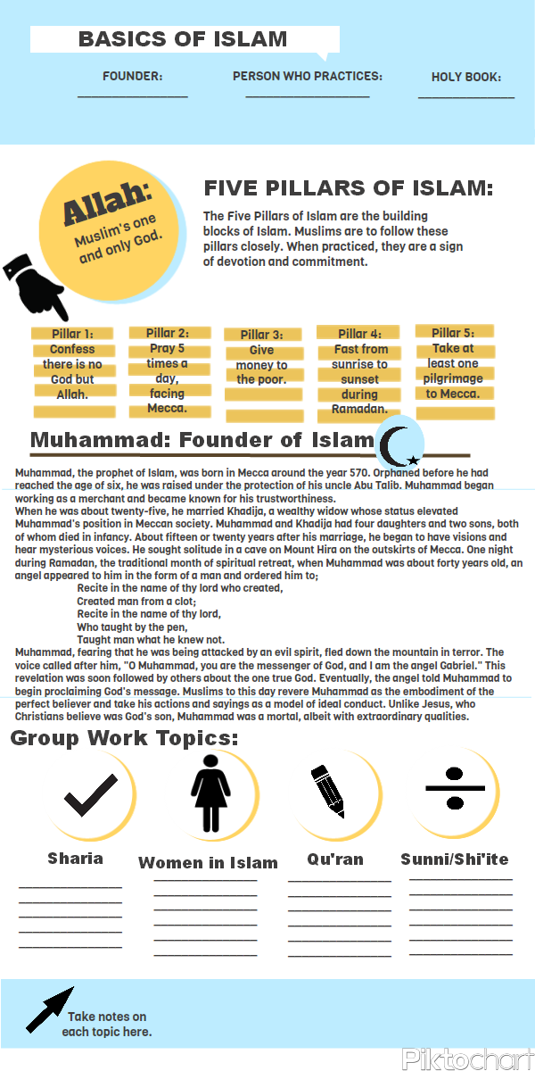
Name:
Period:
Date:

How would daily life for a Muslim differ from that of a Christian or Jew?

Why would Muslims pilgrimage to Mecca?

Look back at Muhammad’s conversation with Gabriel. What did the angel tell Muhammad he was to do?

According to Islamic belief, how is Muhammad similar to and/or different from Abraham, Moses and Jesus?

Comparing Religions
Topics for Venn Diagram: Founder, Holy Book, Holy City, Holidays, Rituals/Practices, Beliefs, others?

Christianity
Islam
Judaism

Sharia: Islamic Law
All aspects of a Muslim's life are governed by Sharia. Sharia law comes from a combination of sources including the Qur'an (the Muslim holy book), the Hadith (sayings and conduct of the prophet Muhammad) and fatwas (the rulings of Islamic scholars).

Sharia, or Islamic law, influences the legal code and politics in most Muslim countries. A movement to allow Sharia to govern personal status law, a set of regulations that pertain to marriage, divorce, inheritance, and custody, is even expanding into the West.

What is Sharia?
Also meaning "path" in Arabic, sharia guides all aspects of Muslim life, including daily routines, familial and religious obligations, and financial dealings. It is derived primarily from the Quran and the Sunna--the sayings, practices, and teachings of the Prophet Mohammed.
Sharia developed several hundred years after the Prophet Mohammed's death in 632 CE as the Islamic empire expanded to the edge of North Africa in the West and to China in the East. Since the Prophet Mohammed was considered the most holy of all believers, his life and ways became a model for all other Muslims and were collected by scholars into what is known as the hadith. As each city tried to reconcile local customs and Islam, hadith literature grew and developed into different Islamic teachings. Named after the scholars that inspired them, they differ in the weight each applies to the sources from which sharia is derived, the Quran, hadith, Islamic scholars, and consensus of the community. Some scholars believe sharia should be loosely followed, others believe that if you break the sharia law, you should be killed or stoned to death.

Whether democracy and Islam can coexist is a topic of heated debate. Some conservative Muslims argue democracy is a purely Western concept imposed on Muslim countries while more liberal Muslims argue the freedoms of a democracy is supported by sharia law.

http://www.cfr.org/religion/islam-governing-under-sharia/p8034

Questions to discuss:
- How would you define the Sharia?
- What parts of a Muslim’s life does the Sharia determine or guide?
- Why would there be different interpretations of the Sharia?
- Why wouldn’t the Sharia be able to fit into a democracy, or can it? What does the Sharia base its laws from? What is a basic freedom of living in a democracy?
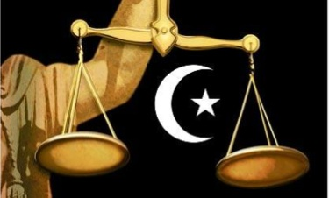

Women in Islam

Some extreme Muslim groups have misinterpreted the Qu’ran and have treated women poorly as a result, however, In the divine relationship between men and women, Islam has assigned a position of dignity and honor to women. Such beneficent regulation is essential for peace, comfort, happiness, continuation of the species and progress. The Holy Quran emphasizes that God in His perfect wisdom has created all species in pairs, and so men and women have been created of the same species; as is said: “He created you from a single being; then of the same kind made
its mate.” (39:7)

The Hijab:
There are a myriad of reasons why women wear a hijab (or a head covering), but the easy, one sentence answer is, because they believe God has made it an obligation for believing women. In the Quran God tells the believing men and women to lower their gaze and to dress modestly. He (God) specifically addresses women when He asks them not to show off their adornment, except that which is apparent, and draw their veils over their bodies. (Quran 24:30-31)

These verses of Quran are known as the verses of hijab and it is the consensus of Islamic scholars that they make the wearing of hijab mandatory. Some countries, such as Saudi Arabia and Qatar do enforce a dress code. Women there are expected to cover their hair and wear some sort of loose fitting, full-length garment over their clothes. However, for the majority of Muslim women around the world, to cover, or not to cover, is a freely made choice. God requires Muslim women to dress modestly and to wear the hijab in public and in the presence of men who are not close relatives.

While those who seek to ban hijab refer to it as a symbol of gender based repression, the women who choose to wear a scarf, or to wear hijab, in the broadest sense of the word, do so by making personal decisions and independent choices. They view it as a right and not a burden. Nor do these women regard hijab as a sign of oppression. Women who wear hijab often describe themselves as being “set free” from society’s unrealistic fashion culture.

Hijab frees women from being thought of as sexual objects of desire or from being valued for their looks, or body shape rather then their minds and intellect. No longer slaves to consumerism, hijab liberates women from the need to conform to unrealistic stereotypes and images dictated by the media. Women wearing hijab have expressed that dressing modestly and covering their hair, minimises sexual harassment in the workplace. The aura of privacy created by hijab is indicative of the great value Islam places upon women.

It is true that in some families and in some cultures women are forced to wear hijab but this is not the norm. The Quran clearly states that there is no compulsion in religion (2:256). Women who choose to wear hijab do not make the decision lightly. In fact many women testify that they faced great animosity from their Muslim or non-Muslim families when they decided to cover. Across the globe there are numerous instances of women having to defend their right to wear the hijab.
http://www.islamreligion.com/articles/2770/ // http://www.alislam.org/library/WOMANINISLAM.pdf

Questions to discuss:
- What is a hijab?
- What are specific reasons why women wear a hijab?
- Why do some people disagree with women wearing a hijab?
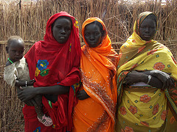
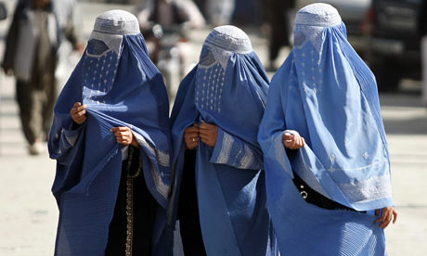

THE QURAN
Islam appeared in the form of a book: the Quran. Muslims, consider the Quran (sometimes spelled "Koran") to be the Word of God as transmitted by the Angel Gabriel, in the Arabic language, through the Prophet Muhammad. The Muslim view, moreover, is that the Quran supersedes earlier revelations; it is regarded as their summation and completion. It is the final revelation, as Muhammad is regarded as the final prophet - 'the Seal of the Prophets."
In a very real sense the Quran is the mentor of millions of Muslims, Arab and non-Arab alike; it shapes their everyday life, anchors them to a unique system of law, and inspires them by its guiding principles. Written in noble language, this Holy Text has done more than move multitudes to tears and ecstasy; it has also, for almost fourteen hundred years, illuminated the lives of Muslims with its eloquent message of uncompromising monotheism, human dignity, righteous living, individual responsibility, and social justice. For countless millions, consequently, it has been the single most important force in guiding their religious, social, and cultural lives. Indeed, the Quran is the cornerstone on which the edifice of Islamic civilization has been built.
http://www.islamicity.com/mosque/ihame/Ref1.htm /// http://www.al-islam.org/short/quraanlessons.htm

Respecting the Qu’ran:
1. A part of the Qur’aan carries the same respect as the entire Qur’aan. Allah says: When the Qur’aan is recited, listen to it (7:204).
2. The Qur’aan should always be carried with proper care. When your bag contains the Qur’aan, or a part of it, take extra care of the bag. Keep the bag slowly on the desk or floor instead of letting it fall on its own. Use both hands to remove the Qur’aan from your bag, kiss the cover of the Qur’aan, place it slowly on a desk (or on a wooden carrier specially built for holding the Qur’aan) and open the pages gently.
3. When the Qur’aan is being recited, listen to it and be attentive (7:204). If you are busy with something else then at least do not disturb the recitation by talking, for example, or making noise.
4. The Qur’aan should be recited regularly. It is disrespect to keep the Holy Qur’aan unread. Prophet Muhammad (s) said: Brighten your homes with reciting Qur’aan; do not turn them into graves. Surely the house in which a lot of recitation takes place enjoys many blessings and the members benefit from it. Such a household shines for the inhabitants of Heaven as stars shine to the inhabitants of the earth.
5. Children should get familiarized with the Qur’aan early in their lives.
6. It is the right and respect of the Qur’aan that it should be followed. It is also the right and respect of the Qur’aan that those who have the knowledge of the Qur’aan should teach it to others. This is among the noblest acts. Prophet Muhammad (s) said: The best of you is he who learns the Qur’an and teaches it.
Questions to discuss:
- What language is the Qu’ran written in? Why do you think it can only be written in this language?
- Who is the primary author of the Qur’an?
- What does the Qu’ran teach Muslims about day-to-day living?
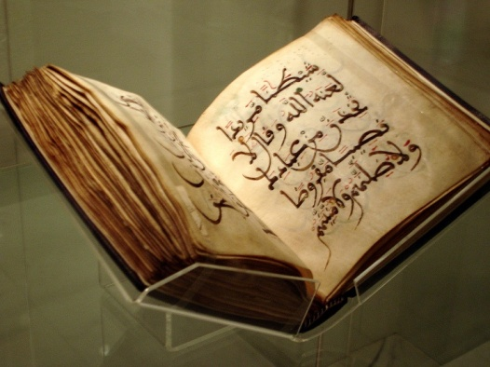
- Why do Muslims respect and cherish the Qu’ran so much?
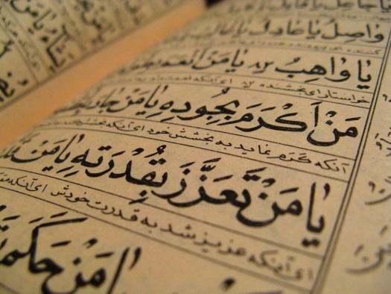

Sunni vs. Shiite Muslims

The words Sunni and Shi'a appear regularly in stories about the Muslim world but few people know what they really mean. Religion permeates every aspect of life in Muslim countries and understanding Sunni and Shi'a beliefs is important in understanding the modern Muslim world.

Introduction
The division between Sunnis and Shi'as is the largest and oldest in the history of Islam. They both agree on the fundamentals of Islam and share the same Holy Book (The Qur'an), but there are differences mostly derived from their different historical experiences, political and social developments, as well as ethnic composition.
These differences originate from the question of who would succeed the Prophet Muhammad as leader of the emerging Muslim community after his death. To understand them, we need to know a bit about the Prophet's life and political and spiritual legacy.

The Prophet Muhammad
When the Prophet died in the early 7th century he left not only the religion of Islam but also a community of about one hundred thousand Muslims organized as an Islamic state on the Arabian Peninsula. It was the question of who should succeed the Prophet and lead the fledgling Islamic state that created the divide.
The larger group of Muslims chose Abu Bakr, a close Companion of the Prophet, as the leader and he was accepted as such by much of the community which saw the succession in political and not spiritual terms. However another smaller group, believed that the Prophet's son-in-law and cousin, Ali, should be leader. They understood that the Prophet had appointed the son-in-law as the sole interpreter of his legacy, in both political and spiritual terms. In the end the close friend, Abu Bakr became the leader.

Leadership claims
Muslims who believe that Abu Bakr should have been the Prophet's successor have come to be known as Sunni Muslims. Those who believe the son-in-law, Ali should have been the Prophet's successor are now known as Shi'a (Shiite) Muslims. It was only later that these terms came into use.
The use of the word "successor" should not be confused to mean that those leaders that came after the Prophet Muhammad were also prophets - both Shi'a and Sunni agree that Muhammad was the final prophet.

Questions to discuss:
- What created the division between Sunni and Shiite Muslims?
- What potential tensions exist between Sunni and Shiite Muslims?
- Are there more Sunni or Shiite Muslims in the world today? Which countries have Shiite Muslims as the majority?
- From what you know, do Sunni and Shiite Muslims have more similarities than differences? Why?

